Project:7 Centralized Auth with FreeIPA
Tuesday, March 3, 2026
2:25 PM
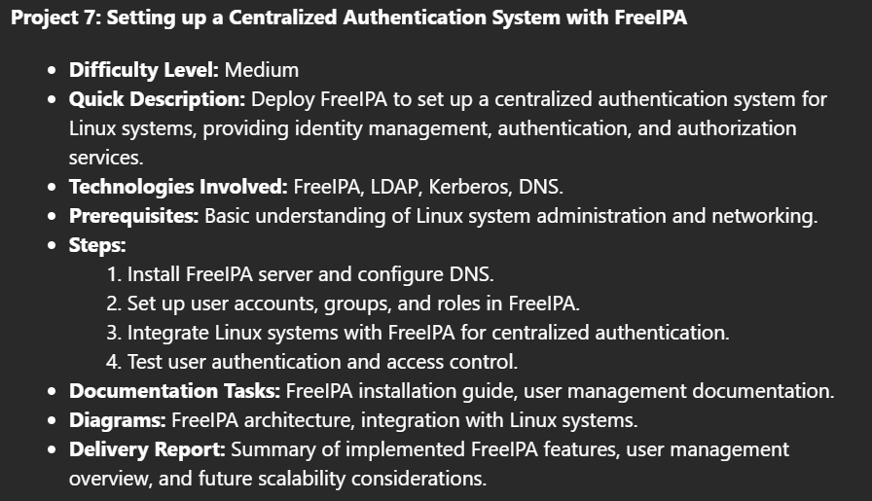
\\oinfs001\IT Programs\Cisco Any Connect\Oinofita Certificates

What is freeipa ?

FreeIPA - Identity, Policy, Audit

Identity
Manage Linux users and client hosts in your realm from one central location with CLI, Web UI or RPC access. Enable Single Sign On authentication for all your systems, services and applications.
Policy
Define Kerberos authentication and authorization policies for your identities. Control services like DNS, SUDO, SELinux or autofs.

From <https://www.freeipa.org/>
TASK 1 : Install FreeIPA server and configure DNS

Dnf install freeipa-server
Dnf install freeipa-server-dns

Or ipa-server-install --setup-dns
I HAVE SETTED TWO PASSWORDS

adminroot1
adminroot123 -- this is for the ( kinit admin local) in order to authenticate the admin@INTERNAL.LOCAL
In order to configure the dns

bash
- ipa-server-install --setup-dns

!!! BUT AT FIRST I NEED TO CONFIGURE IT NOT TO THE INTERNET.
!!! BUT FOR THE INTERNAL LOCAL (cause I'm not finding any available)

bash
- Sudo hostnamectl set-hostname ipakaps.internal.local

Now we want to change the ip to ours inside the hosts

- Vi/etc/hosts :

192.168.56.110 | ipakaps.internal.local | ipakaps

Bash
- Sudo ipa-server-install --setup-dns
Answer these:
Ipakaps.internal.local
Internal.local
INTERNAL.LOCAL

adminroot1
adminroot123

Do you want forwarders - yes
And everything else

TASK 2 : Create User accounts , Groups and Roles

STEP 1 : enter inside the FreeIPA
CLI:
bash
# Authenticate as admin
kinit admin
# Enter your admin password when prompted

Explanation: FreeIPA offers both web GUI and CLI. The web interface is more intuitive, while CLI is better for automation.

Step 2: Understanding FreeIPA Structure
Hierarchy:
- Users: Individual accounts
- Groups: Collections of users
- Roles: Define what actions can be performed
- Privileges: Specific permissions
- Permissions: Granular access controls

Step 3: Create User Groups First

Via CLI:
bash
# Create departmental groups
ipa group-add developers --desc="Development Team"
ipa group-add sysadmins --desc="System Administrators"
ipa group-add finance --desc="Finance Department"
ipa group-add managers --desc="Management Team"

Expected output:
------------------------
Added group "developers"
------------------------
Group name: developers
Description: Development Team
GID: 588200003
-----------------------
Added group "sysadmins"
-----------------------
Group name: sysadmins
Description: System Administrators
GID: 588200004
---------------------
Added group "finance"
---------------------
Group name: finance
Description: Finance Department
GID: 588200005
----------------------
Added group "managers"
----------------------
Group name: managers
Description: Management Team
GID: 588200006

# Create functional groups
ipa group-add database-users --desc="Database Access Users"
ipa group-add vpn-users --desc="VPN Access Users"

Expected Output :
----------------------------
Added group "database-users"
----------------------------
Group name: database-users
Description: Database Access Users
GID: 588200007
-----------------------
Added group "vpn-users"
-----------------------
Group name: vpn-users
Description: VPN Access Users
GID: 588200008

Explanation: Groups organize users by department, function, or access needs. Create groups before users to assign memberships during user creation.

Step 4: Create User Accounts

Basically the ipa user-add {name-of-user} … sets alone the user
And the same for the group ipa group-add-member {name-of-group} --users={name-of-user}
Via CLI:
bash
# Create users with detailed information
[root@ipakaps ~]# ipa user-add jdoe \
--first=John \
--last=Doe \
--email=john.doe@internal.local \
--phone="+1-555-1234" \
--title="Senior Developer"

ipa user-add mjohnson \
--first=Mary \
--last=Johnson \
--email=mary.johnson@internal.local \
--phone="+1-555-2345" \
--title="Frontend Developer"

ipa user-add dlee \
--first=David \
--last=Lee \
--email=david.lee@internal.local \
--phone="+1-555-3456" \
--title="Backend Developer"

Add users individually to the developers group

bash
ipa group-add-member developers --users=jdoe
ipa group-add-member developers --users=mjohnson
ipa group-add-member developers --users=dlee

Expected Output :

Group name: developers
Description: Development Team
GID: 588200003
Member users: jdoe
-------------------------
Number of members added 1
-------------------------
Group name: developers
Description: Development Team
GID: 588200003
Member users: jdoe, mjohnson
-------------------------
Number of members added 1
-------------------------
Group name: developers
Description: Development Team
GID: 588200003
Member users: jdoe, mjohnson, dlee
-------------------------
Number of members added 1
-------------------------

Explanation: Each user gets a unique username (UID), and you can add extensive profile information that integrates with email systems and directories.

Step 2: Verify the group membership
# Check the developers group now has all members
ipa group-show developers

Step 3: Now create the remaining users and add them to groups
Create the system administrators:
bash
ipa user-add asmith --first=Alice --last=Smith --email=alice.smith@internal.local --phone="+1-555-4567" --title="Senior System Administrator"
ipa user-add rbrown --first=Robert --last=Brown --email=robert.brown@internal.local --phone="+1-555-5678" --title="Network Administrator"
# Add them to sysadmins group individually
ipa group-add-member sysadmins --users=asmith
ipa group-add-member sysadmins --users=rbrown
Create finance users:
bash
ipa user-add swilson --first=Sarah --last=Wilson --email=sarah.wilson@internal.local --phone="+1-555-6789" --title="Finance Manager"
ipa user-add tgarcia --first=Thomas --last=Garcia --email=thomas.garcia@internal.local --phone="+1-555-7890" --title="Accountant"
# Add them to finance group individually
ipa group-add-member finance --users=swilson
ipa group-add-member finance --users=tgarcia
Create managers:
bash
ipa user-add cjones --first=Carol --last=Jones --email=carol.jones@internal.local --phone="+1-555-8901" --title="IT Director"
ipa user-add mdavis --first=Michael --last=Davis --email=michael.davis@internal.local --phone="+1-555-9012" --title="Operations Manager"
# Add them to managers group individually
ipa group-add-member managers --users=cjones
ipa group-add-member managers --users=mdavis

HERE ARE ALL THE USERS AND THE GROUPS WE CREATED !!

NOTICE THE USERS AND THE GROUPS

And all the users

[root@ipakaps ~]# ipa user-find --all
----------------
11 users matched
----------------
dn: uid=admin,cn=users,cn=accounts,dc=internal,dc=local
User login: admin
Last name: Administrator
Full name: Administrator
Home directory: /home/admin
GECOS: Administrator
Login shell: /bin/bash
Principal name: admin@INTERNAL.LOCAL
Principal alias: admin@INTERNAL.LOCAL, root@INTERNAL.LOCAL
User password expiration: 20260602134337Z
UID: 588200000
GID: 588200000
Account disabled: False
Preserved user: False
Member of groups: admins, trust admins
ipantsecurityidentifier: S-1-5-21-1979196419-131720125-4178475967-500
ipauniqueid: 2983a902-17cf-11f1-82a7-080027bb3b6e
krbextradata: AAIJN6hpcm9vdC9hZG1pbkBJTlRFUk5BTC5MT0NBTAA=
krblastadminunlock: 20260304134337Z
krblastpwdchange: 20260304134337Z
objectclass: top, person, posixaccount, krbprincipalaux, krbticketpolicyaux,
inetuser, ipaobject, ipasshuser, ipaSshGroupOfPubKeys, ipaNTUserAttrs

dn: uid=asmith,cn=users,cn=accounts,dc=internal,dc=local
User login: asmith
First name: Alice
Last name: Smith
Full name: Alice Smith
Display name: Alice Smith
Initials: AS
Home directory: /home/asmith
GECOS: Alice Smith
Login shell: /bin/sh
Principal name: asmith@INTERNAL.LOCAL
Principal alias: asmith@INTERNAL.LOCAL
Email address: alice.smith@internal.local
UID: 588200009
GID: 588200009
Telephone Number: +1-555-5678
Job Title: System Administrator
Account disabled: False
Preserved user: False
Member of groups: ipausers, sysadmins, database-users, vpn-users
ipantsecurityidentifier: S-1-5-21-1979196419-131720125-4178475967-1009
ipauniqueid: e803ee46-17d4-11f1-98eb-080027bb3b6e
mepmanagedentry: cn=asmith,cn=groups,cn=accounts,dc=internal,dc=local
objectclass: top, person, organizationalperson, inetorgperson, inetuser,
posixaccount, krbprincipalaux, krbticketpolicyaux, ipaobject,
ipasshuser, ipaSshGroupOfPubKeys, mepOriginEntry, ipantuserattrs

… and many more same ..

--------->>>>> CONTINUES THE LIST TO THE NEXT SIDED TAB

dn: uid=jdoe,cn=users,cn=accounts,dc=internal,dc=local
User login: jdoe
First name: John
Last name: Doe
Full name: John Doe
Display name: John Doe
Initials: JD
Home directory: /home/jdoe
GECOS: John Doe
Login shell: /bin/sh
Principal name: jdoe@INTERNAL.LOCAL
Principal alias: jdoe@INTERNAL.LOCAL
Email address: john.doe@internal.local
UID: 588200011
GID: 588200011
Telephone Number: +1-555-1234
Job Title: Senior Developer
Account disabled: False
Preserved user: False
Member of groups: ipausers, developers, database-users, vpn-users
ipantsecurityidentifier: S-1-5-21-1979196419-131720125-4178475967-1011
ipauniqueid: 5bb538a4-17d5-11f1-98d7-080027bb3b6e
mepmanagedentry: cn=jdoe,cn=groups,cn=accounts,dc=internal,dc=local
objectclass: top, person, organizationalperson, inetorgperson, inetuser,
posixaccount, krbprincipalaux, krbticketpolicyaux, ipaobject,
ipasshuser, ipaSshGroupOfPubKeys, mepOriginEntry, ipantuserattrs

…. And many more same …
-----------------------------
Number of entries returned 11
-----------------------------
End result :

Ipa group-find --all

-------
[root@ipakaps ~]# ipa group-find --all
-----------------
10 groups matched
-----------------
dn: cn=admins,cn=groups,cn=accounts,dc=internal,dc=local
Group name: admins
Description: Account administrators group
GID: 588200000
Member users: admin
ipantsecurityidentifier: S-1-5-21-1979196419-131720125-4178475967-512
ipauniqueid: 29984574-17cf-11f1-8e65-080027bb3b6e
objectclass: top, groupofnames, posixgroup, ipausergroup, ipaobject, nestedGroup,
ipaNTGroupAttrs

dn: cn=database-users,cn=groups,cn=accounts,dc=internal,dc=local
Group name: database-users
Description: Database Access Users
GID: 588200007
Member users: jdoe, dlee, asmith
ipantsecurityidentifier: S-1-5-21-1979196419-131720125-4178475967-1007
ipauniqueid: 82945de8-17d4-11f1-a815-080027bb3b6e
objectclass: top, groupofnames, nestedgroup, ipausergroup, ipaobject, posixgroup,
ipantgroupattrs

dn: cn=developers,cn=groups,cn=accounts,dc=internal,dc=local
Group name: developers
Description: Development Team
GID: 588200003
Member users: jdoe, mjohnson, dlee
ipantsecurityidentifier: S-1-5-21-1979196419-131720125-4178475967-1003
ipauniqueid: 45e62cd2-17d4-11f1-bd79-080027bb3b6e
objectclass: top, groupofnames, nestedgroup, ipausergroup, ipaobject, posixgroup,
ipantgroupattrs

dn: cn=editors,cn=groups,cn=accounts,dc=internal,dc=local
Group name: editors
Description: Limited admins who can edit other users
GID: 588200002
ipantsecurityidentifier: S-1-5-21-1979196419-131720125-4178475967-1002
ipauniqueid: 29a5e01c-17cf-11f1-b3c9-080027bb3b6e
objectclass: top, groupofnames, posixgroup, ipausergroup, ipaobject, nestedGroup,
ipantgroupattrs
ipantgroupattrs
-----------------------------
Number of entries returned 10
-----------------------------
[root@ipakaps ~]#

Now we want to implement the Kerberos Authentication !

At first
systemctl status krb5kdc

Systemctl enable krb5kdc

And then we want to set up a simple authentication system

And then try to do an advanced setup with security hardening

[root@ipakaps ~]# ipa group-find --all
ipa: ERROR: Ticket expired

-- In that situation my kerberos authentication ticket has expired and I need to authenticate as the admin again !!!!
What is Kerberos Authentication????
Kerberos is a network authentication protocol that uses tickets instead of passwords to prove identity. Think of it like a secure "passport system" for your network.

To my server the AS - is my FreeIPA server that grants the tickets
And the TGS is the server that serves the tickets

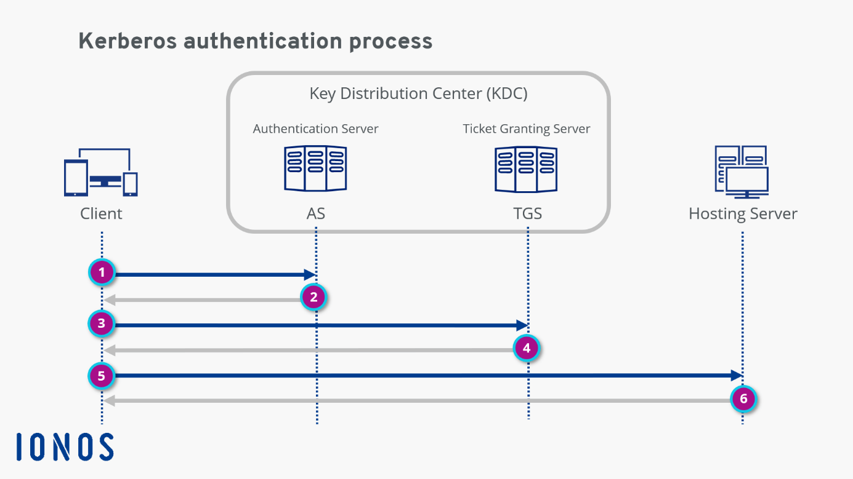

The Authentication Process:

1. You typed: kinit manager
↓
2. System contacted KDC (your FreeIPA server)
↓
3. KDC asked for password
↓
4. You entered password
↓
5. KDC verified password against LDAP directory
↓
6. KDC issued TGT (Ticket Granting Ticket)
↓
7. TGT stored locally for future use

Step-by-Step Kerberos Authentication for Manager User

Step 1: Verify Manager User's Kerberos Setup
bash
# Check manager's Kerberos principal (already exists!)
ipa user-show manager
grep "Principal name"

What you see:
- Principal name: manager@INTERNAL.LOCAL (Kerberos identity)
- Principal alias: manager@INTERNAL.LOCAL (Alternative identity)
This means Kerberos is already configured for the manager user!

Step 2: Set/Verify Manager's Password
bash
# Set or reset manager's password (needed for Kerberos)
ipa passwd manager
# You'll be prompted:
# New Password: [enter strong password]
# Enter New Password again to verify: [repeat password]
Important: The password you set here will be used for Kerberos authentication.

Step 3: Test Basic Kerberos Authentication

Clear any existing tickets first:
bash
# Clear any existing Kerberos tickets
kdestroy
# Verify no tickets exist
klist
# Should show: "No credentials cache found"

Authenticate manager user:
bash
# Authenticate as manager
kinit manager
# You'll see:
# Password for manager@INTERNAL.LOCAL: [enter the password you just set]

Verify authentication worked:
bash
# Check your Kerberos tickets
klist
# Expected output:
# Ticket cache: FILE:/tmp/krb5cc_0
# Default principal: manager@INTERNAL.LOCAL
#
# Valid starting Expires Service principal
# 03/04/26 16:30:00 03/05/26 02:30:00 krbtgt/INTERNAL.LOCAL@INTERNAL.LOCAL
Step 4: Understand What Just Happened
The Authentication Process:

1. You typed: kinit manager
↓
2. System contacted KDC (your FreeIPA server)
↓
3. KDC asked for password
↓
4. You entered password
↓
5. KDC verified password against LDAP directory
↓
6. KDC issued TGT (Ticket Granting Ticket)
↓
7. TGT stored locally for future use
ki
What the ticket contains:
- Identity: manager@INTERNAL.LOCAL
- Realm: INTERNAL.LOCAL
- Validity: 10 hours (default)
- Encryption: Strong encryption for security
This is really interesting !!!

Cause I were logged in as admin but
When I ssh to manager and it was invalid
I remained signed in as the manager

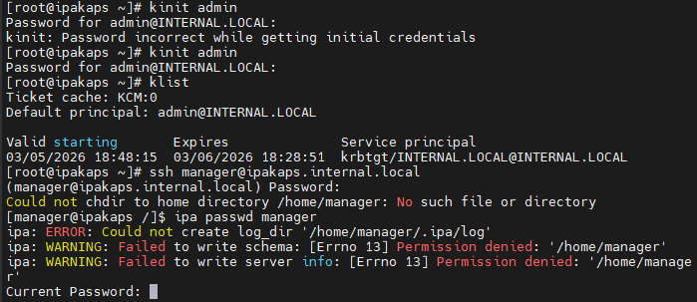

Also when you need to connect via ssh through kerberos to your users

At first you need to create a home directory for that user

# As root, create the home directory for manager
mkdir -p /home/manager
# Set proper ownership and permissions
chown manager:manager /home/manager
chmod 755 /home/manager
# Copy skeleton files
cp -r /etc/skel/. /home/manager/
chown -R manager:manager /home/manager
# Verify the home directory
ls -la /home/manager

ARCHITECTURE

FreeIPA Architecture Overview
Domain: INTERNAL.LOCAL
Realm: INTERNAL.LOCAL
Server: ipakaps (your FreeIPA server)

Architecture Principles
Identity Source : FreeIPA
Authentication : Kerberos
Authorization : Group-based RBAC
Directory Backend : LDAP
Certificate Mgmt : Integrated CA
Name Resolution : Integrated DNS

WHAT I WOULD LIKE TO ADD IS :

---->>> SUDO POLICIES

---->>>> HOST GROUPS
Example:
linux-servers
dev-servers
production-servers
---->>>> Access Control Model,
Create SUDO Rules by Role Tiers

What I did:
- Configured DNS so client can find IPA server
- Joined the client machine to the IPA domain
- Set up the infrastructure for authentication

Its like basically similar to the concept of adding a machine to the active directory

For the remote client side

sudo hostnamectl set-hostname client.internal.local

sudo vi /etc/resolv.conf also for /etc/hosts
nameserver 192.168.56.110
search internal.local
domain internal.local

[root@client0 ~]# vi /resolv/conf
[root@client0 ~]# vi /etc/resolv.conf
[root@client0 ~]# nslookup ipakaps.internal.local
Server: 192.168.56.110
Address: 192.168.56.110#53

sudo ipa-client-install --domain=internal.local --server=ipakaps.internal.local --realm=INTERNAL.LOCAL --hostname=client.internal.local --mkhomedir --enable-dns-updates --force --no-dns-sshfp
This program will set up IPA client.
Version 4.12.2

Autodiscovery of servers for failover cannot work with this configuration.
If you proceed with the installation, services will be configured to always access the discovered server for all operations and will not fail over to other servers in case of failure.
Proceed with fixed values and no DNS discovery? [no]: yes
Do you want to configure chrony with NTP server or pool address? [no]: no
Client hostname: client.internal.local
Realm: INTERNAL.LOCAL
DNS Domain: internal.local
IPA Server: ipakaps.internal.local
BaseDN: dc=internal,dc=local

Continue to configure the system with these values? [no]: yes
Synchronizing time
No SRV records of NTP servers found and no NTP server or pool address was provided.
Using default chrony configuration.
Attempting to sync time with chronyc.
Process chronyc waitsync failed to sync time!
Unable to sync time with chrony server, assuming the time is in sync. Please check that 123 UDP port is opened, and any time server is on network.
User authorized to enroll computers: admin
Password for admin@INTERNAL.LOCAL:
Successfully retrieved CA cert
Subject: CN=Certificate Authority,O=INTERNAL.LOCAL
Issuer: CN=Certificate Authority,O=INTERNAL.LOCAL
Valid From: 2026-03-04 13:38:14+00:00
Valid Until: 2046-03-04 13:38:14+00:00

Enrolled in IPA realm INTERNAL.LOCAL
Created /etc/ipa/default.conf
Configured /etc/sssd/sssd.conf
Systemwide CA database updated.
Hostname (client.internal.local) does not have A/AAAA record.
Failed to update DNS records.
Missing A/AAAA record(s) for host client.internal.local: 192.168.56.102.
Missing reverse record(s) for address(es): 192.168.56.102.
Adding SSH public key from /etc/ssh/ssh_host_ecdsa_key.pub
Adding SSH public key from /etc/ssh/ssh_host_ed25519_key.pub
Adding SSH public key from /etc/ssh/ssh_host_rsa_key.pub
SSSD enabled
Configured /etc/openldap/ldap.conf
Configured /etc/ssh/ssh_config
Configured /etc/ssh/sshd_config.d/04-ipa.conf
Configuring internal.local as NIS domain.
Configured /etc/krb5.conf for IPA realm INTERNAL.LOCAL
Client configuration complete.
The ipa-client-install command was successful

AND here

For the ipa server side

Check if DNS is installed in FreeIPA
Run:

ipa dnszone-find

And

Systemctl enable ipa

I'll guide you through configuring your Oracle Linux client (192.168.56.102) to authenticate against your FreeIPA server (192.168.56.110) as an admin with admin priviledges !!! Username : admin
Password:adminroot123

. Here's a step-by-step process:

Prerequisites Check
First, ensure both systems can communicate:
bash
# On client (192.168.56.102)
ping 192.168.56.110
nslookup ipakaps.internal.local 192.168.56.110

Step 1: Configure DNS Resolution
Edit /etc/resolv.conf on the client:
bash
sudo vi /etc/resolv.conf

Add:
plaintext
nameserver 192.168.56.110
search internal.local
domain internal.local

Step 2: Configure Hostname and Hosts File
Set the client's hostname:
bash
sudo hostnamectl set-hostname client.internal.local

Edit /etc/hosts:
bash
sudo vi /etc/hosts
editfile_copyCopy code keyboard_arrow_down
Add:
plaintext
192.168.56.110 ipakaps.internal.local ipakaps
192.168.56.102 client.internal.local client
Step 3: Install Required Packages
bash
sudo dnf install -y ipa-client krb5-workstation
Step 4: Join the Client to FreeIPA Domain
Run the IPA client enrollment:
bash
sudo ipa-client-install \
--domain=internal.local \
--server=ipakaps.internal.local \
--realm=INTERNAL.LOCAL \
--hostname=client.internal.local \
You'll be prompted for:
- Admin username (usually admin)
- Admin password

AURIO THELW NA TO PIASW OLO APO TIN ARXI !!!!

